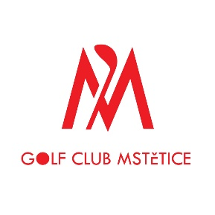

BOHEMIA CUP
JUNIOR GOLF Championship Mstětice

Golf Club Mstětice
21th – 23th October 2022

ENTRY FORM (written in CAPITAL LETTERS)

Nationality:
Male / Female
Last Name:
First Name:
Date of Birth:
(DD/MM/YEAR)
Home Address:
ZIP Code:
City:
Phone:
Email:
Home Club:
Handicap:
(+/- 00.0)
Date:
(DD/MM/YEAR)
Signature of Applicant:
Date
(DD/MM/YEAR)
Golf club Mstětice must receive fully completed Entry Form
until Tuesday, October 18th, 2022, no later than 12:00.
Entry Form must be delivered by e‐mail: academy@golfmstetice.cz

